2016 Greg Settle, Cheryl Settle (Shuswap Vacation Rentals)
Boat Safety Checklist

Individuals renting a pleasure craft fitted with a motor will be required to complete a Rental Boat Safety Check List unless:
1 They have a Canadian Pleasure Craft Operator Card, or
2 They have written proof of having successfully completed a boating safety course prior to April 1, 1999, or nautical certification, or in the case of non-residents proof of competency from their own country.

Operator has satisfied above requirement #1 or #2. Operator Card Number___________________
Those required to complete a rental boat safety check list, must carry on board the co-signed (customer and renter) section of the Rental Boat Safety Check List as proof of competency for the duration of the rental.
PLEASE INITIAL EACH BOX ON THE FORM AS THE SUBJECT IS COVERED
BOATING SAFETY RULES
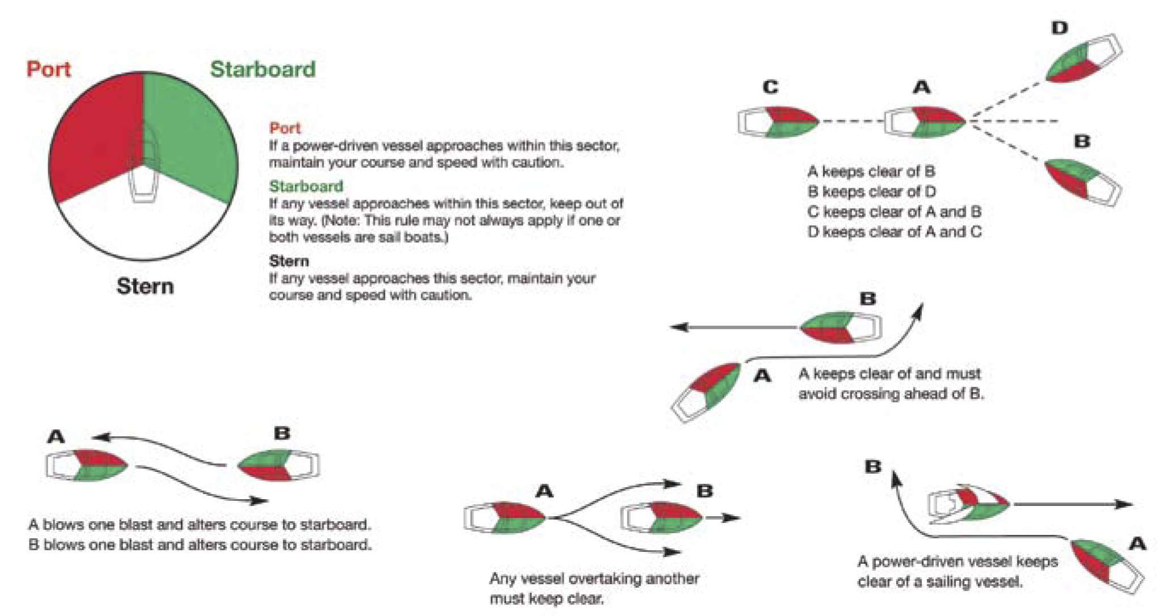
1.1. I, the pleasure craft operator, understand right-away rules for powered boats on the water as per above diagram. I will keep a keen eye out for other, swimmers, kayaks, canoes, tubes, other vessels motorized, other un-motorized vessels and other items and debris in the lake at all times.
1. 2, the pleasure craft operator, confirm that there are the appropriate number and sizes of approved
Personal Floatation Devices or Life Jackets in the boat for the number of people on board. They must fit and should be worn. I am aware that persons operating a pleasure craft without the appropriate number and sizes of approved Personal Floatation Devices or Life Jackets may be subject to ticketing and a fine.
2. I, the pleasure craft operator, am aware that it is illegal to operate a pleasure craft, or to permit others to do so, when under the influence of alcohol, narcotics, or barbiturates.
3. I, the pleasure craft operator, will only allow people who have completed and signed a Rental Boat Safety Check List, valid for the duration of this rental or have other proof of competency, to operate this pleasure craft.
I am aware that persons operating a pleasure craft without proof of competency/age may be subject to ticketing and a fine.
5. I, the pleasure craft operator, understand that pleasure craft fitted with motors must keep clear of non-powered pleasure craft. I also understand that I am responsible for my own wake and wash and the effects that it can have on other pleasure craft, property, wildlife and the environment.
Rental Boat Safety Checklist – page 1 of 2
Rental Boat Safety Checklist – page 2 of 2
6. I, the pleasure craft operator, when involved in an accident must stop, offer assistance and give my identity.
OPERATION OF THE BOAT
7. I, the pleasure craft operator, am aware of how to responsibly operate a pleasure craft and to share waterways in a courteous and respectful manner with others involved in all water-related activities.
8. I, the pleasure craft operator, confirm that the maximum load capacity and number of persons in the pleasure craft will not exceed the amount stated on the capacity plate. If a capacity plate is not fitted, the load capacity and number of persons in the pleasure craft shall not exceed the manufacturer’s recommendation. I am aware of the proper way to distribute weight in the pleasure craft for a safe and comfortable ride and I will keep my passengers in the safest positions at all times - always seated while underway.
9. I, the pleasure craft operator, have been shown the proper procedure for starting and shutting off the engine and will make sure no person is in the water within the vicinity of the pleasure craft before starting and while running the motor.
10. I, the pleasure craft operator, have been shown and understand the operation of the throttle and gear shift lever.
11. I, the pleasure craft operator, know where and how to operate the ignition cut-off (kill) switch. While operating a Personal Water Craft, I will stay tethered to it at all times.
12. I, the pleasure craft operator, am aware of how to depart and approach the dock in a safe and proper manner.
13. I, the pleasure craft operator, am aware of how to respond to grounding, capsizing, and re-boarding
LOCAL HAZARDS AND CONDITIONS
14. I, the pleasure craft operator, am aware of the local navigational aids and their meaning, as well as local hazards and local regulations.
15. I, the pleasure craft operator, will not enter the little river between Shuswap lake and Little Shuswap Lake.
16. I, the pleasure craft operator, shall maintain a proper lookout at all times for other boats, navigational hazards and changes in weather conditions – changes in weather can occur quickly creating conditions dangerous to recreational boats
17. Boat rental customer has been instruction on safe boating practices and Shuswap Lake area hazards
Boat/Motor Type and Description (check one) :

Malibu 1900/190 Mercruiser Parti Kraft Pontoon Supra Wake Surf

Rental Check out: Time____________Day_________Date___________

Rental Check in : Time____________Day_________Date___________

Maximum Number of Persons Permitted in Boat and being towed behind boat combined may not exceed total capacity posted on boat (8 for Malibu ski, 15 for Parti Kraft Pontoon, 16 for Supra Wake surf boat).

Customer Name (print):_____________________________

Customer Signature: ___________________________ Date:______________

Representative of Rental Agency’s Name: Greg Settle

Representative of Rental Agency’s Signature________________________

Date: _____

